Hackerearth question
Factorial! | Basics of Input/Output & Basic Programming Practice Problems
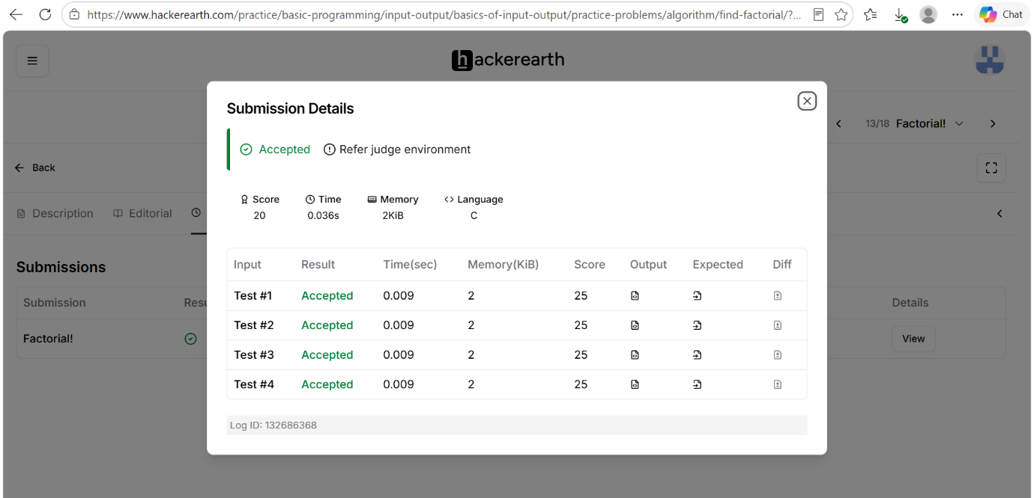

Code
#include <stdio.h>
int main() {
int num;
// Reading input from STDIN
if (scanf("%d", &num) != 1) {
return 0;
}
// Use long long to prevent integer overflow for larger values of N
long long factorial = 1;
// Calculate factorial using a loop
for (int i = 1; i <= num; i++) {
factorial *= i;
}
// Writing output to STDOUT
printf("%lld\n", factorial);
return 0;
}

